#### /var/folders/yw/m895y3qn4456q03kq2s9h1kw0000gn/T/com.microsoft.Word/WebArchiveCopyPasteTempFiles/9971460_fpx.tif?op_sharpen=1&wid=1230&hei=1500&fit=fit,1&$filterxlrg$

#### [Nike](https://www.macys.com/shop/featured/nike) Men's Air Max Torch 4 Running Sneakers

#### /var/folders/yw/m895y3qn4456q03kq2s9h1kw0000gn/T/com.microsoft.Word/WebArchiveCopyPasteTempFiles/9711095_fpx.tif?op_sharpen=1&wid=1230&hei=1500&fit=fit,1&$filterxlrg$

#### [Nike](https://www.macys.com/shop/featured/nike) Men's Air Ring Leader Low Basketball Sneakers

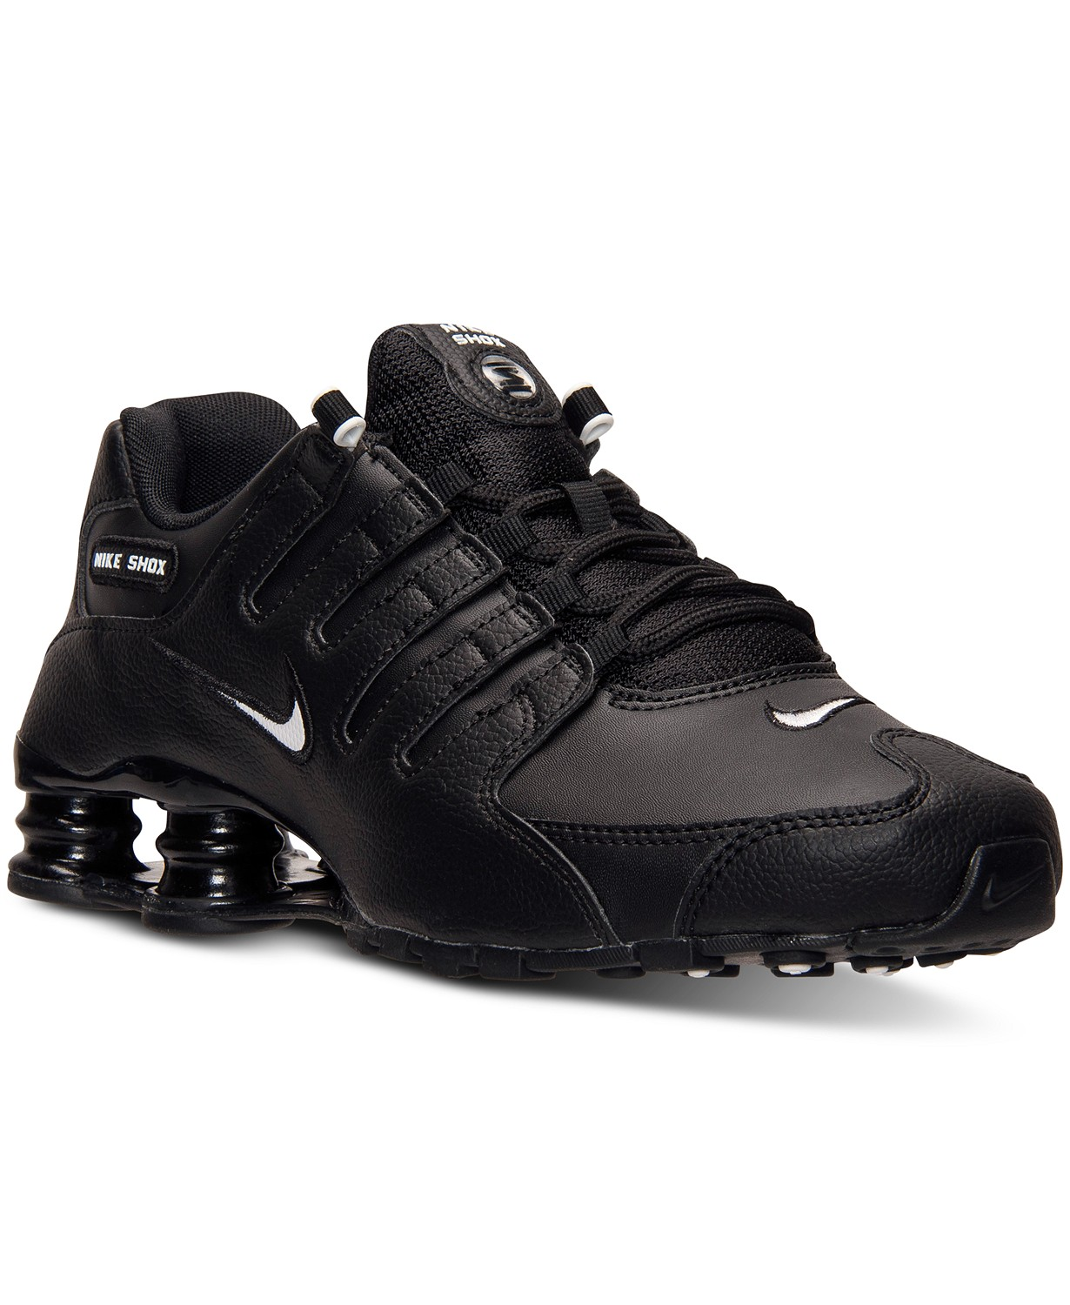

#### [Nike](https://www.macys.com/shop/featured/nike) Men's Shox NZ EU Running Sneakers

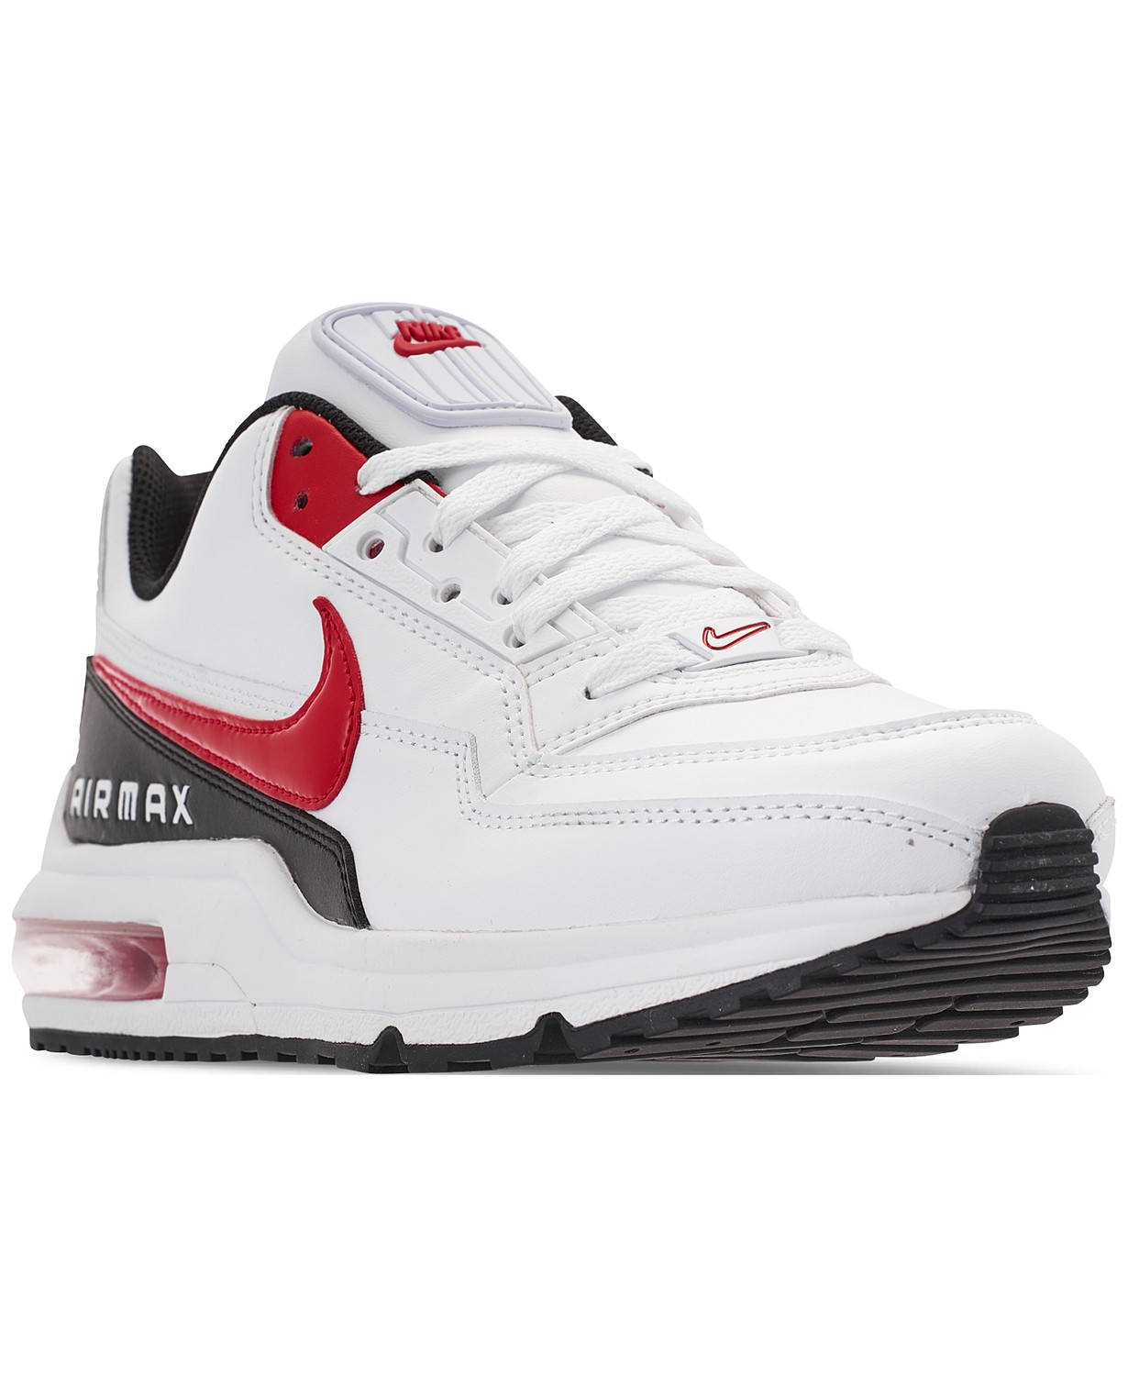

#### [Nike](https://www.macys.com/shop/featured/nike) Men's Air Max LTD 3 Running Sneakers

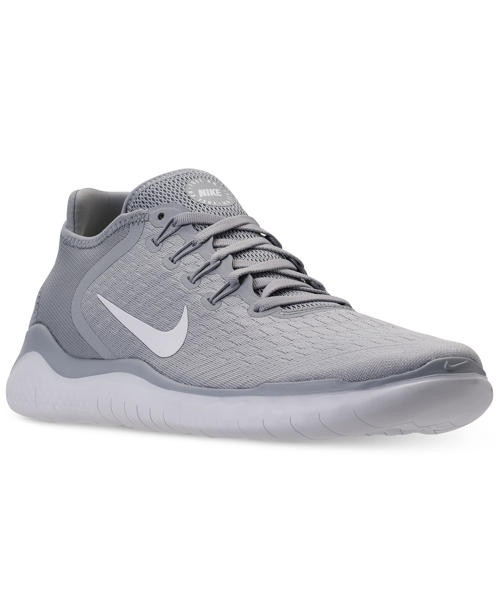

#### [Nike](https://www.macys.com/shop/featured/nike) Men's Free Run 2018 Running Sneakers

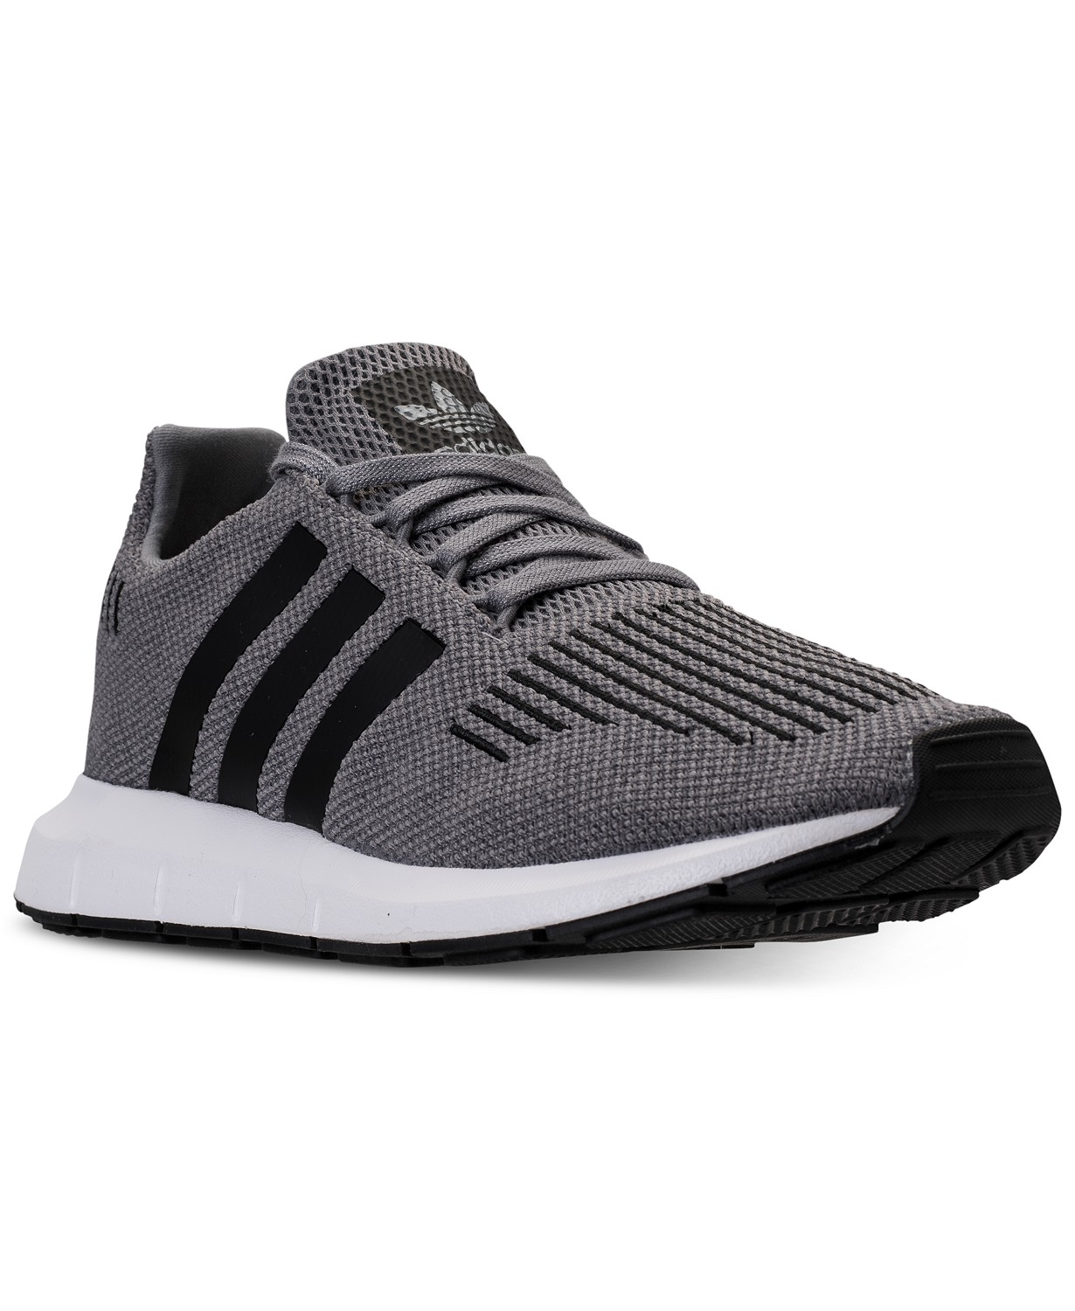

[adidas](https://www.macys.com/shop/featured/adidas) Men's Swift Run Casual Sneakers

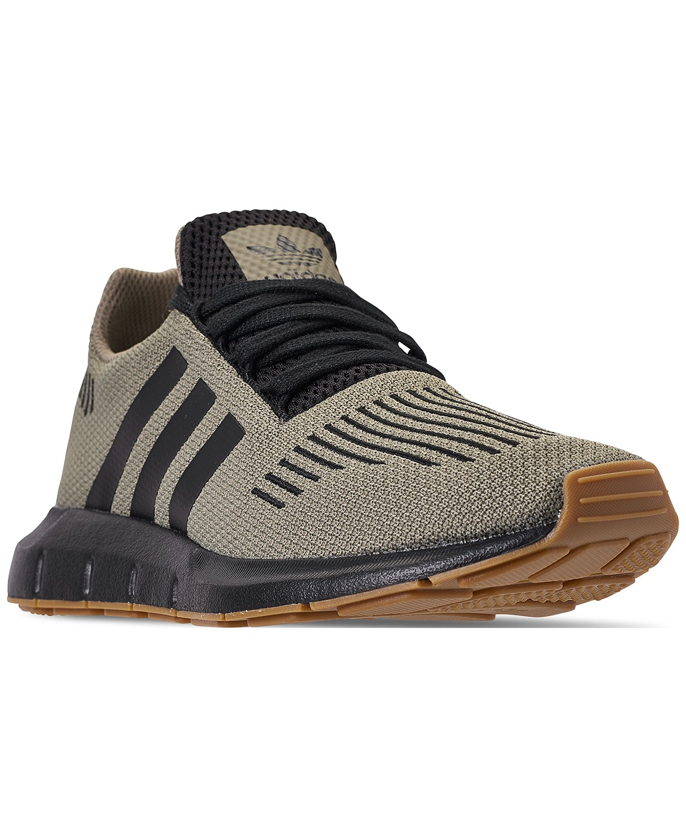

#### [adidas](https://www.macys.com/shop/featured/adidas) Men's Swift Run Casual Sneakers

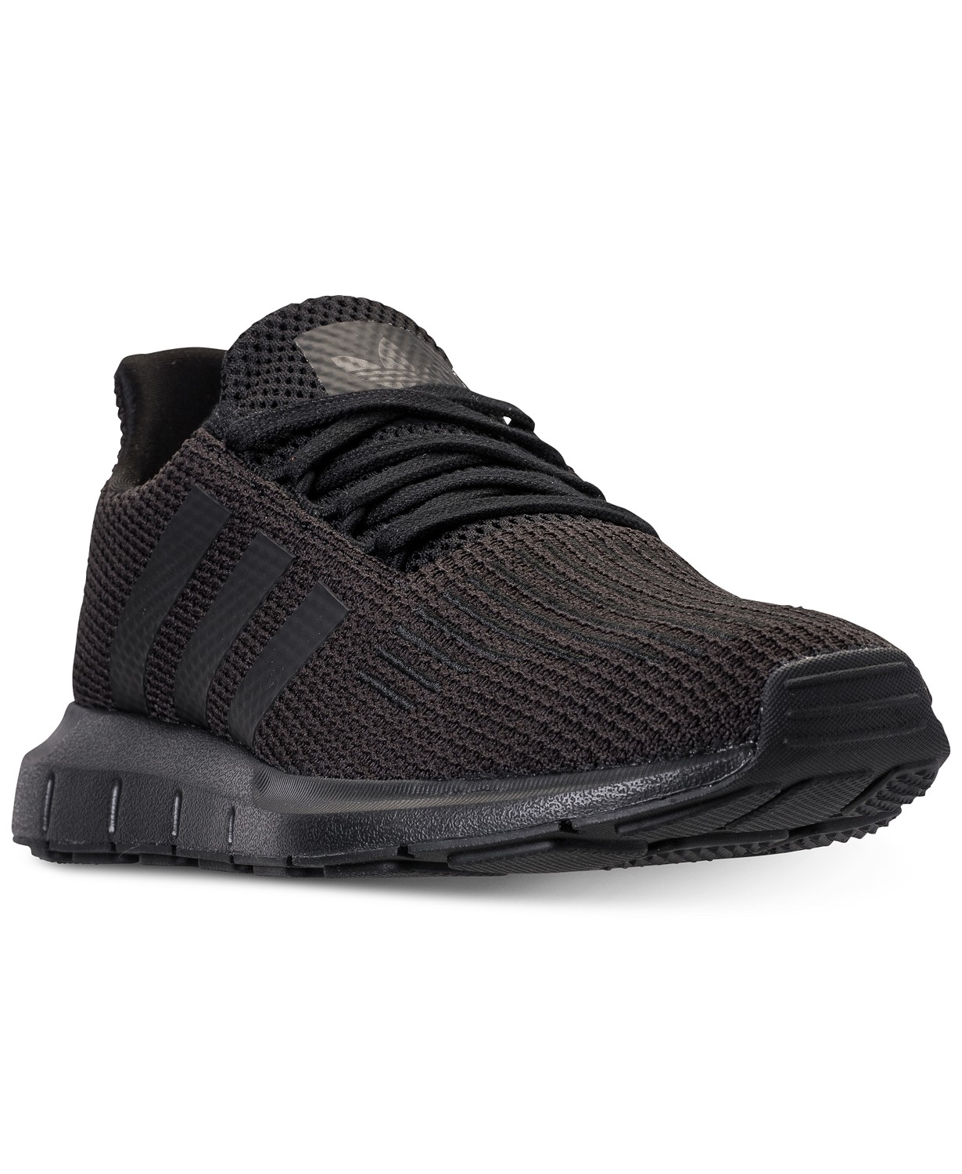

#### [adidas](https://www.macys.com/shop/featured/adidas) Men's Swift Run Casual Sneakers

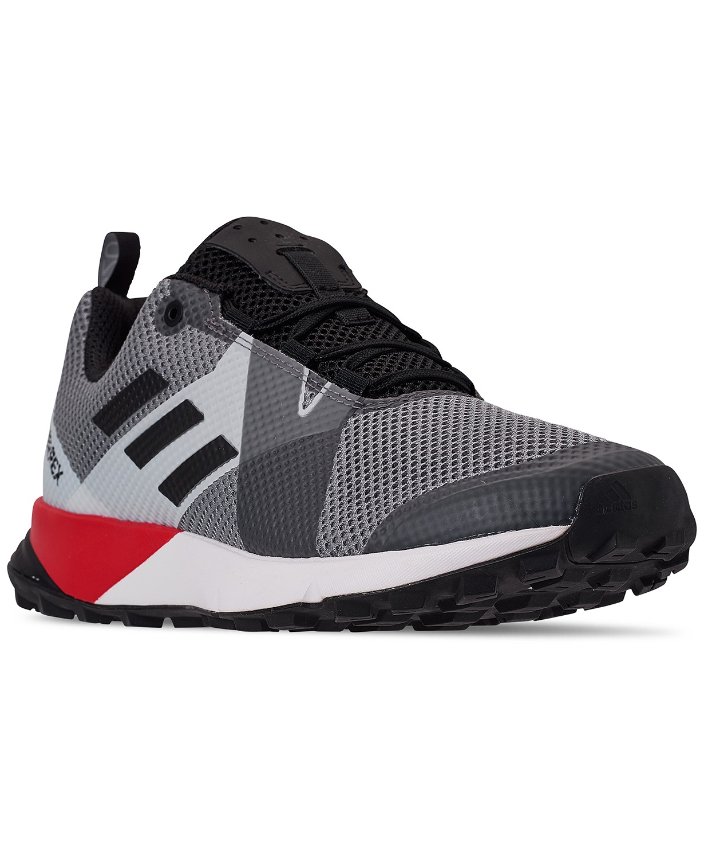

#### [adidas](https://www.macys.com/shop/featured/adidas) Men's Terrex Two Trail Running Sneakers

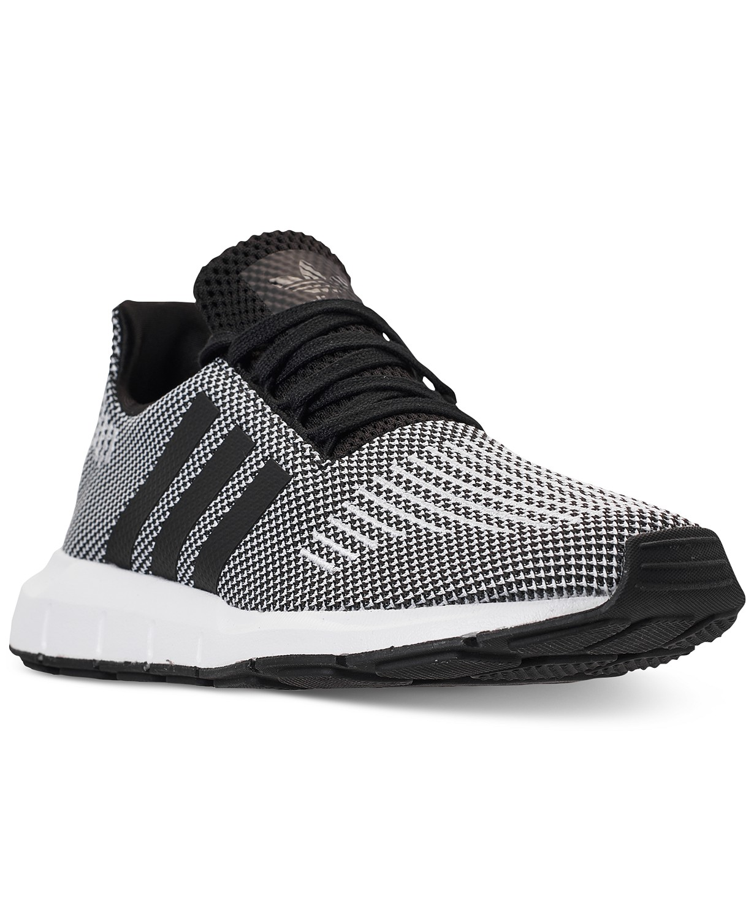

#### [adidas](https://www.macys.com/shop/featured/adidas) Men's Swift Run Casual Sneakers

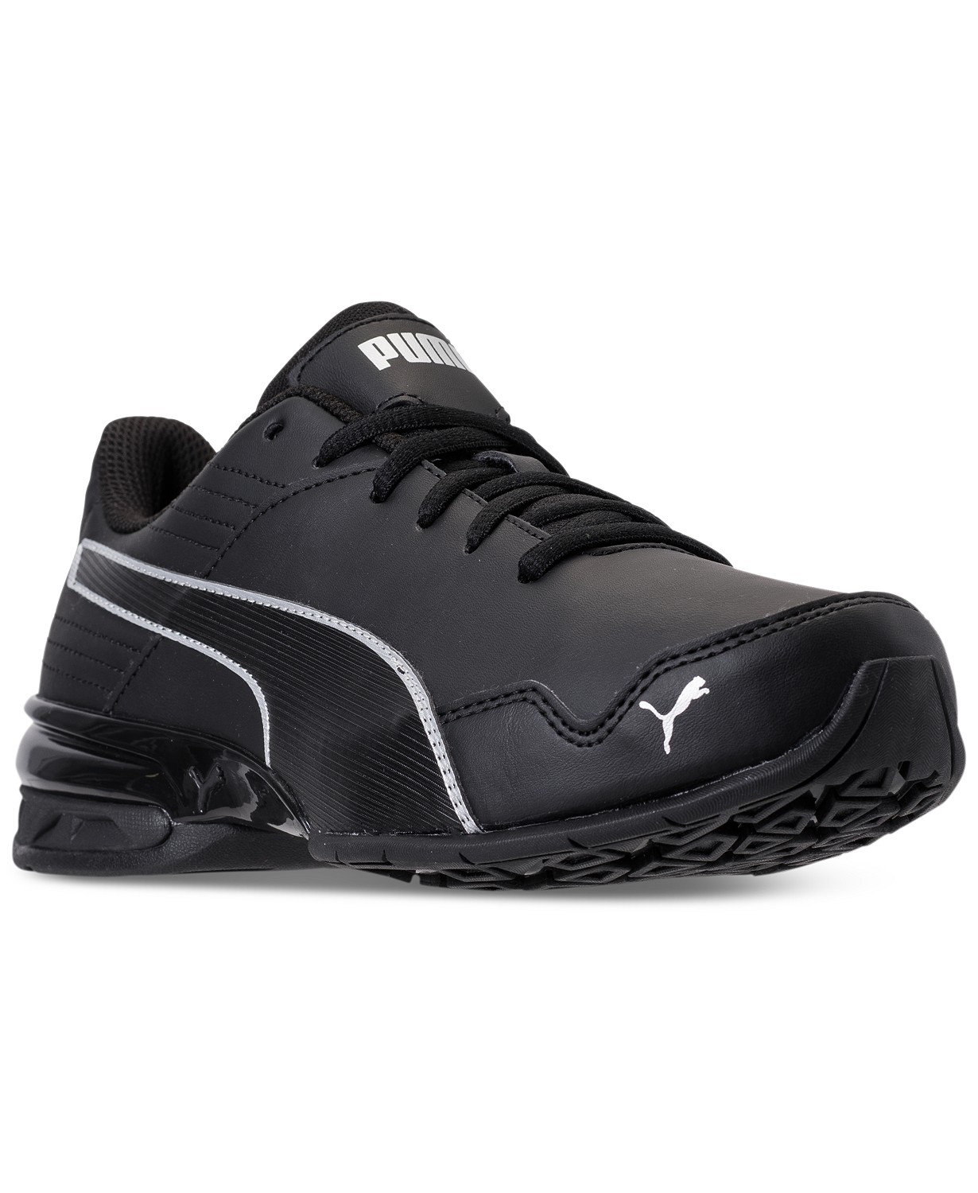

#### [Puma](https://www.macys.com/shop/featured/puma) Men's Super Levitate Running Sneakers

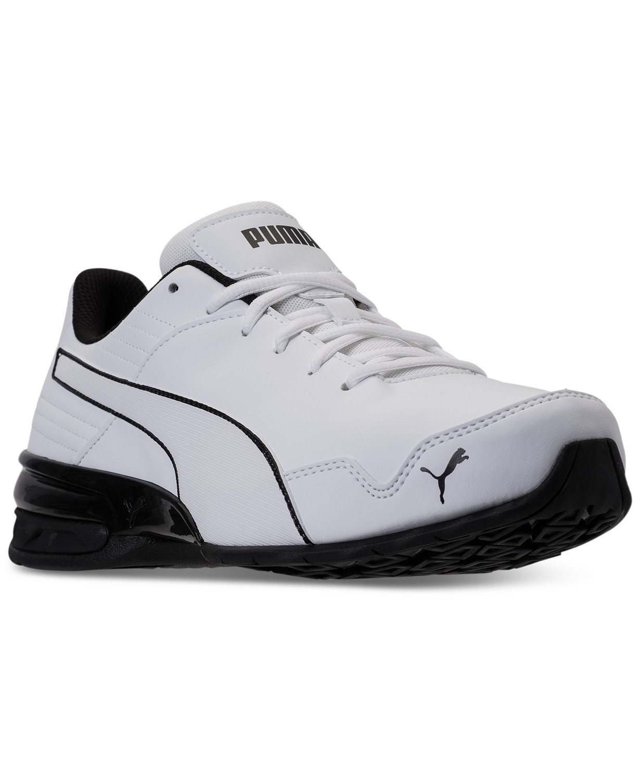

#### [Puma](https://www.macys.com/shop/featured/puma) Men's Super Levitate Running Sneakers

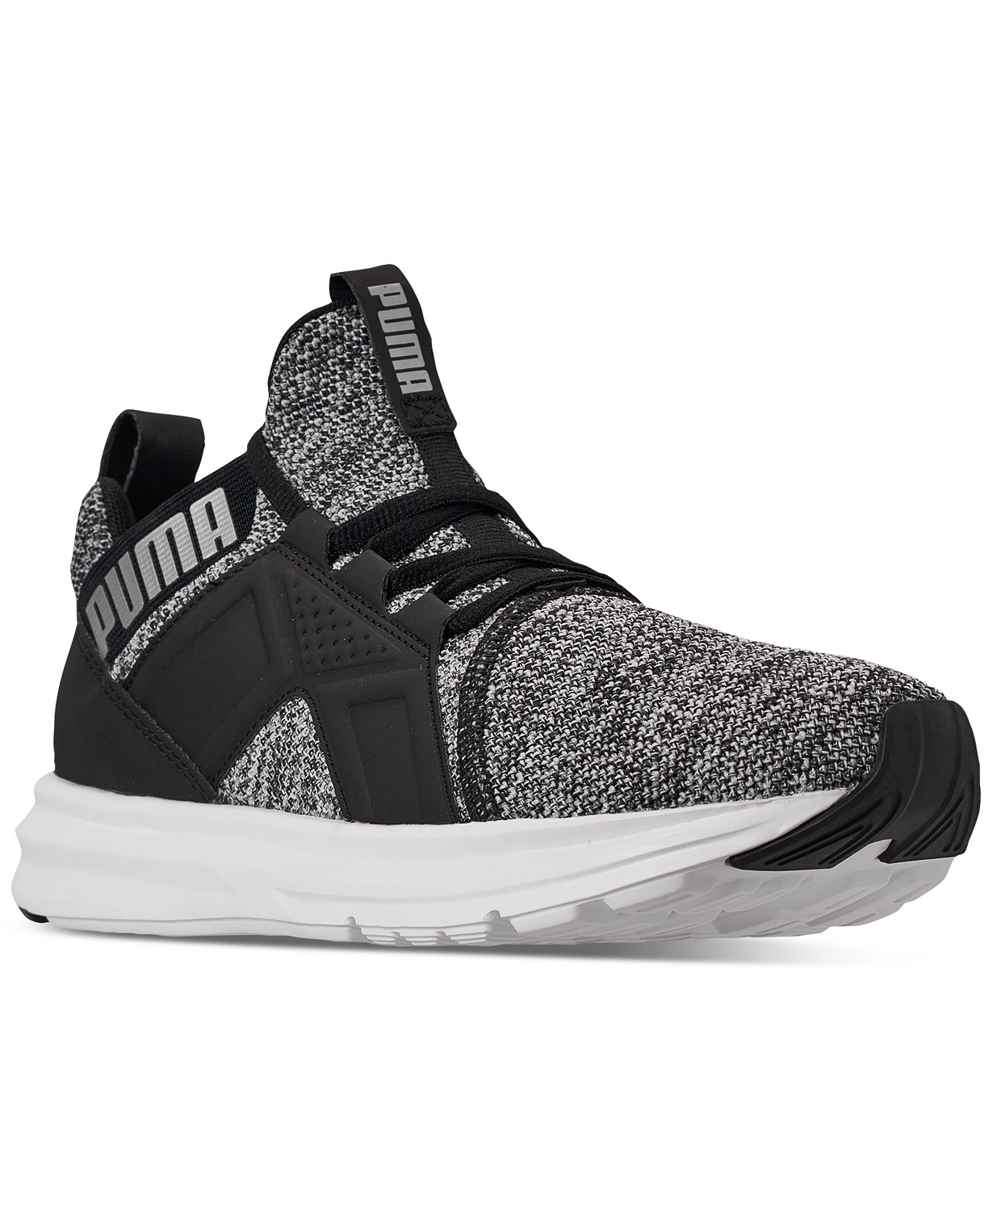

#### [Puma](https://www.macys.com/shop/featured/puma) Men's Enzo Knit NM Casual Sneakers

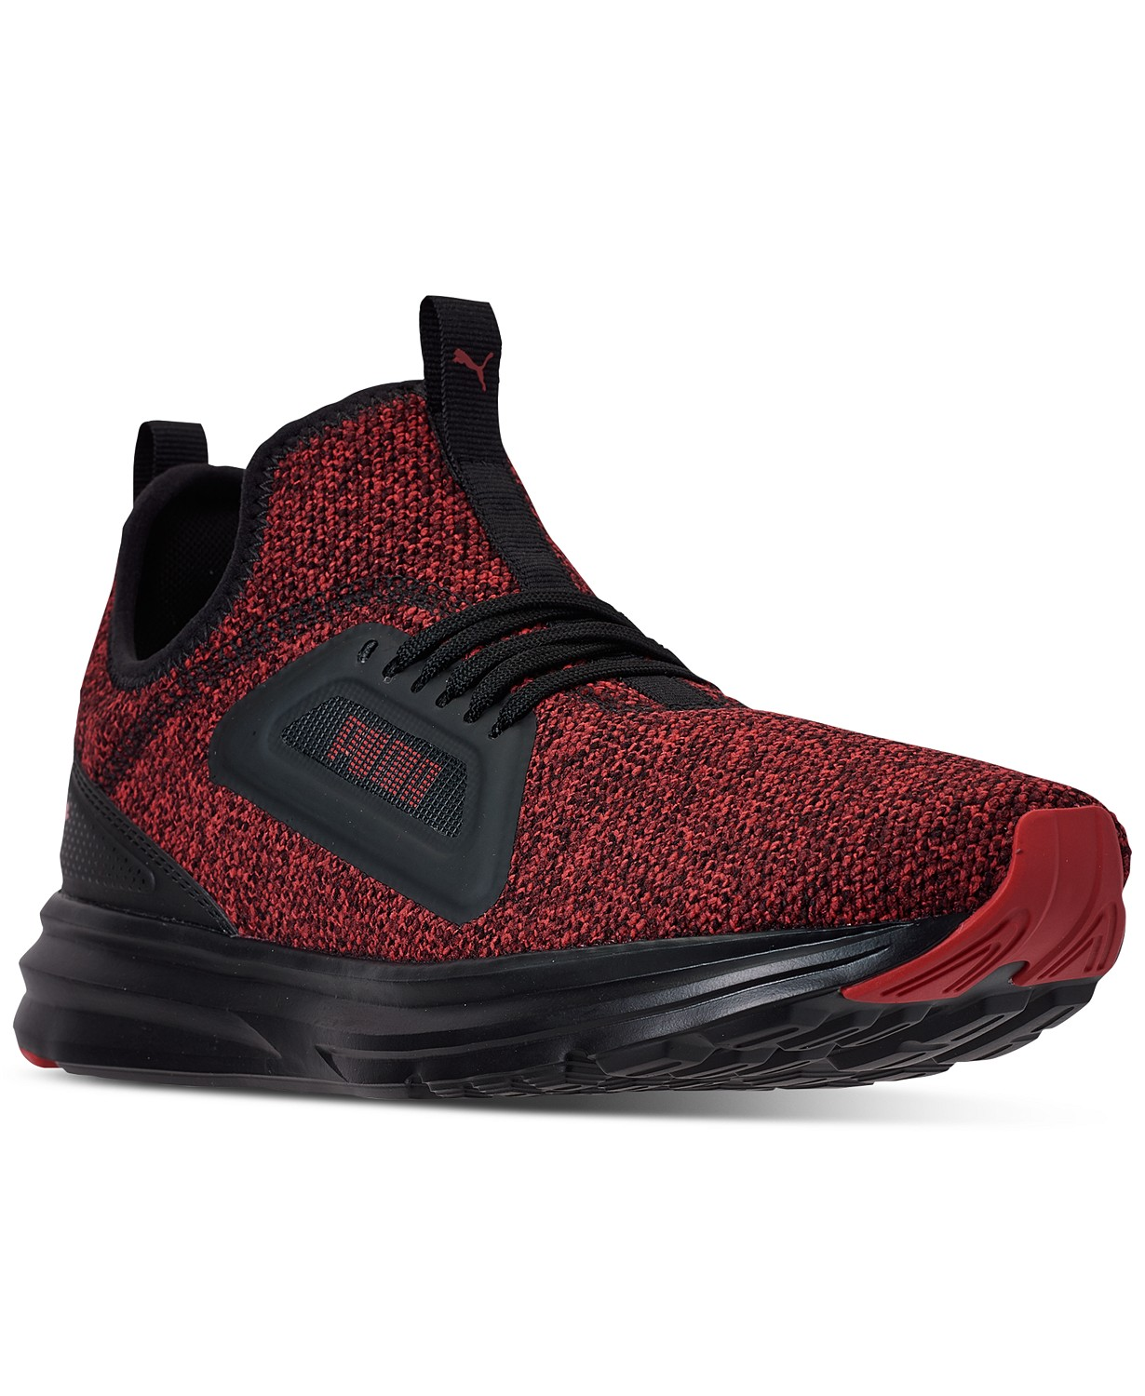

#### [Puma](https://www.macys.com/shop/featured/puma) Men's Enzo Lean Training Sneakers

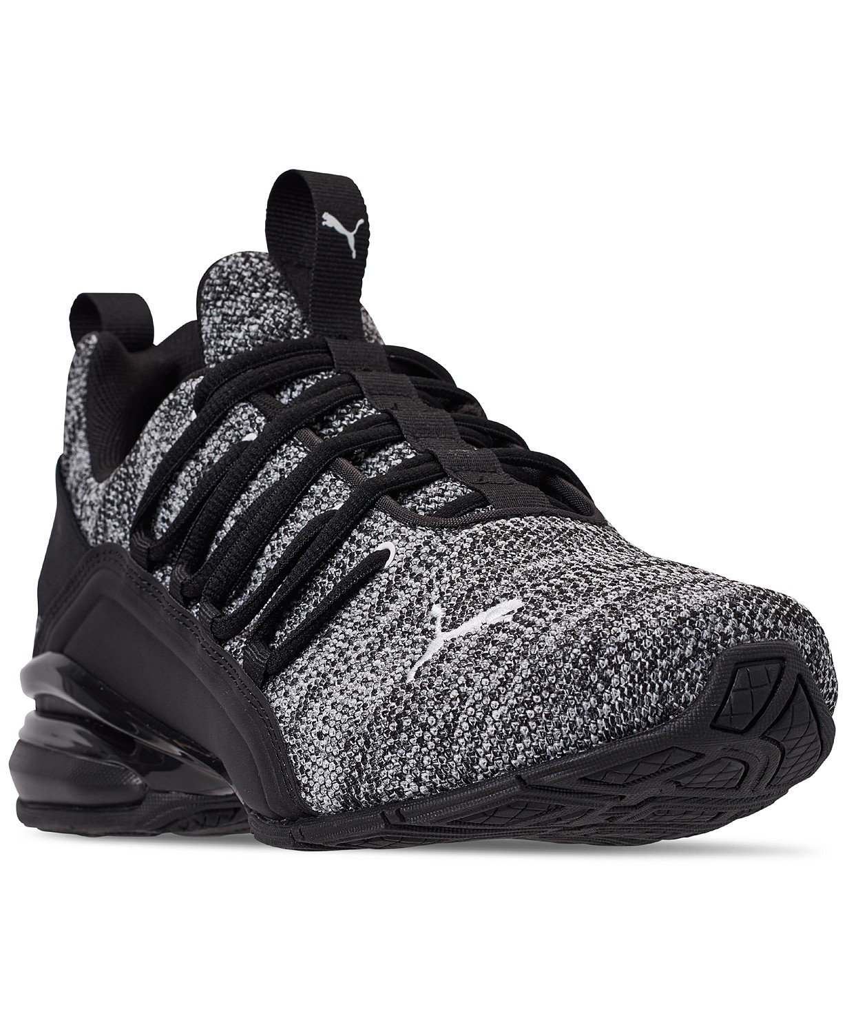

#### [Puma](https://www.macys.com/shop/featured/puma) Men's Axelion Running Sneakers

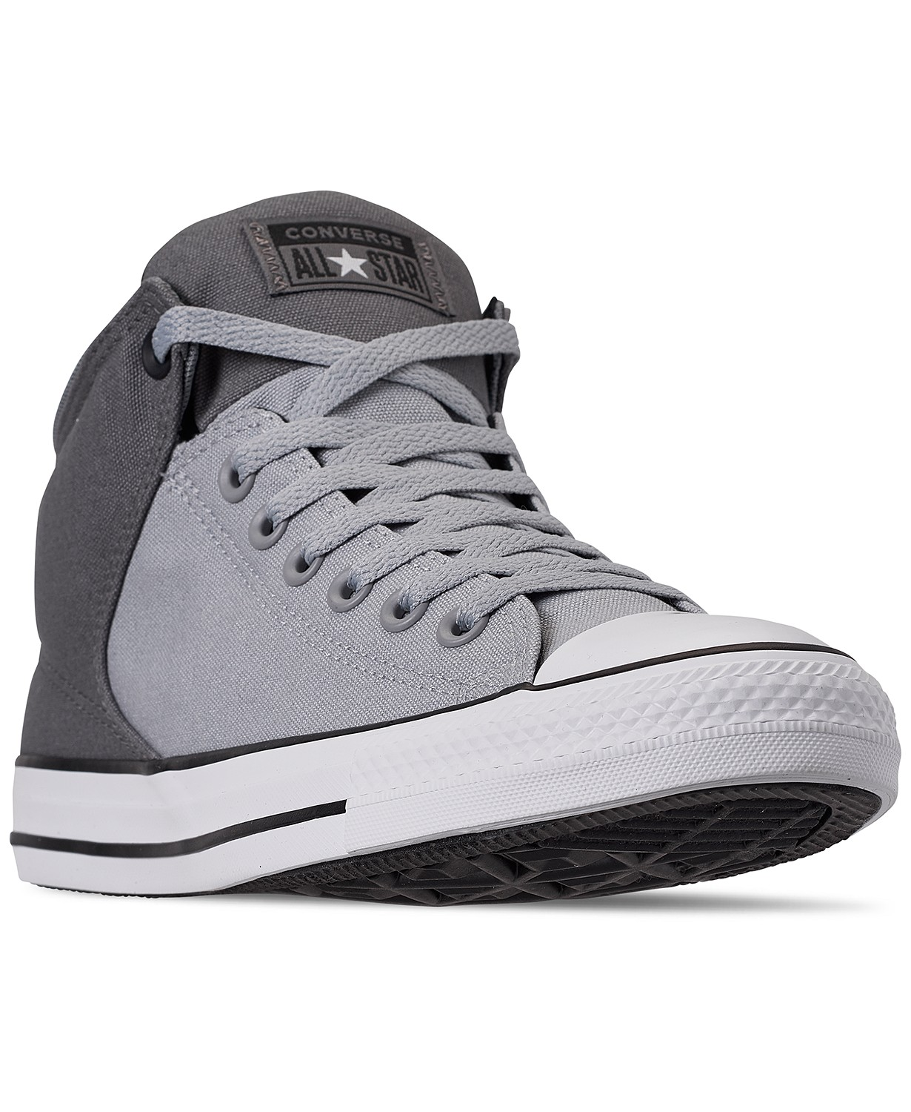

#### [Converse](https://www.macys.com/shop/featured/converse) Men's Chuck Taylor All Star High Street Casual Sneakers

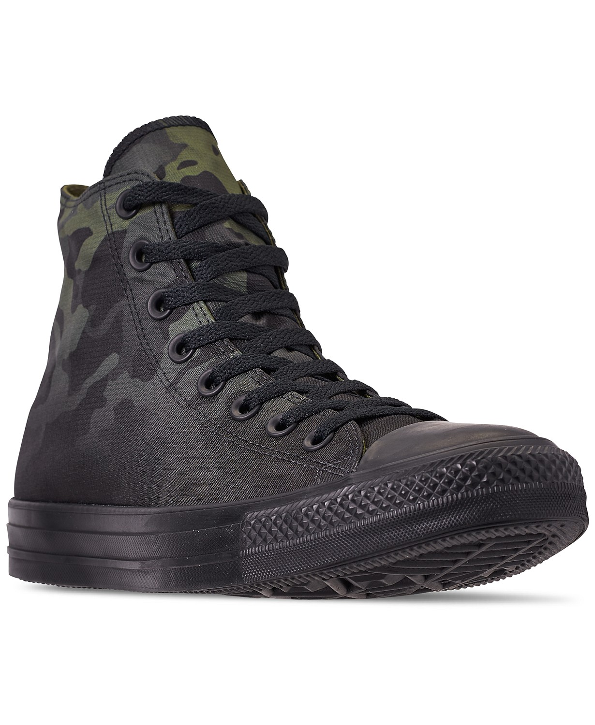

#### [Converse](https://www.macys.com/shop/featured/converse) Men's Chuck Taylor All Star Gradient Camo High Top Casual Sneakers

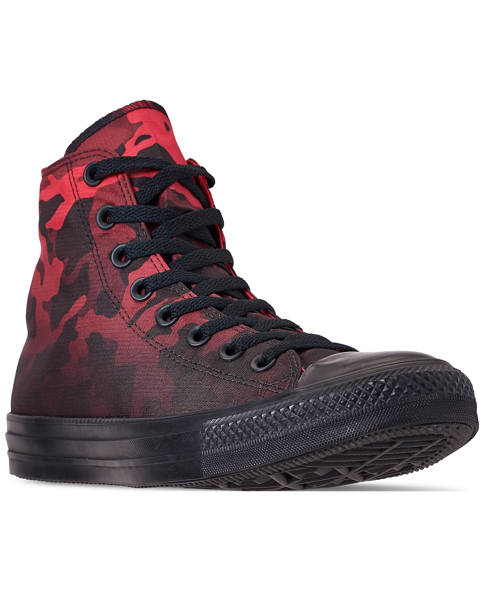

#### [Converse](https://www.macys.com/shop/featured/converse) Men's Chuck Taylor All Star Gradient Camo High Top Casual Sneakers

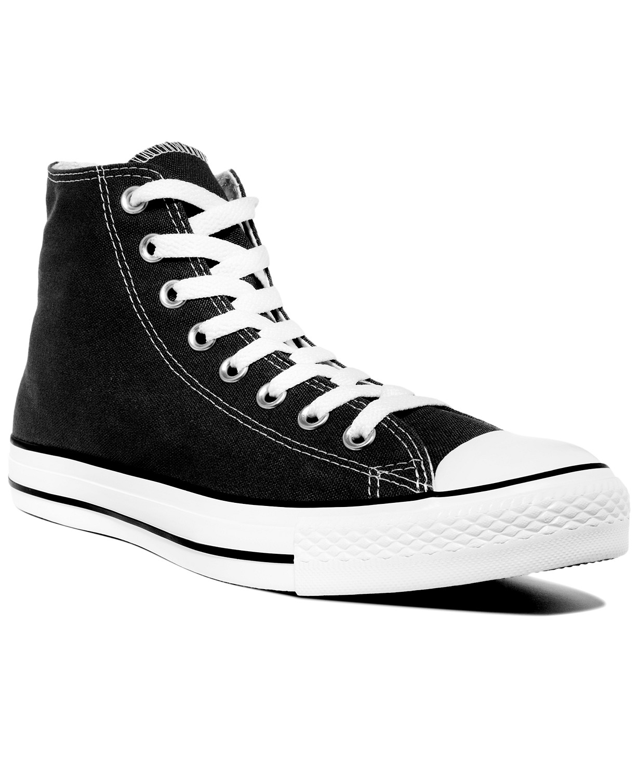

#### [Converse](https://www.macys.com/shop/featured/converse) Men's Chuck Taylor Hi Top Casual Sneakers

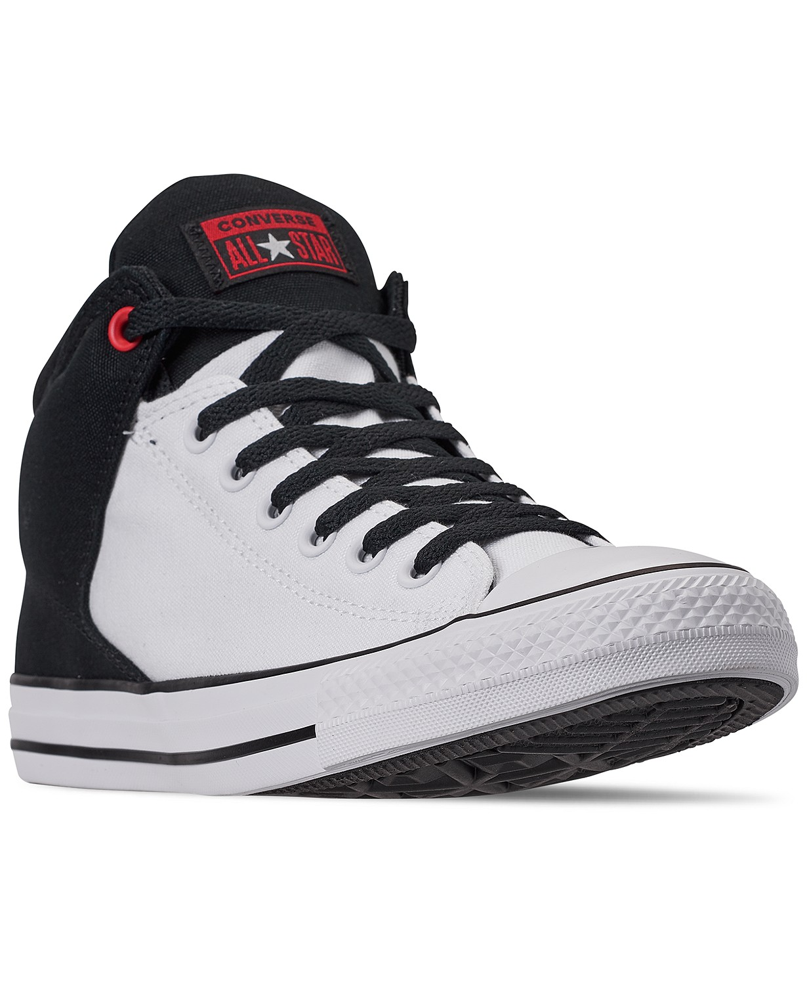

#### [Converse](https://www.macys.com/shop/featured/converse) Men's Chuck Taylor All Star High Street Casual Sneakers

# 

vans CHECKERBOARD SLIP-ON

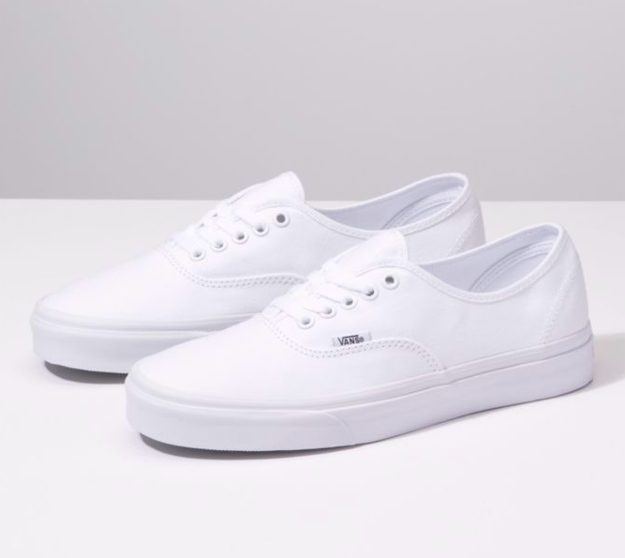

# vans AUTHENTIC

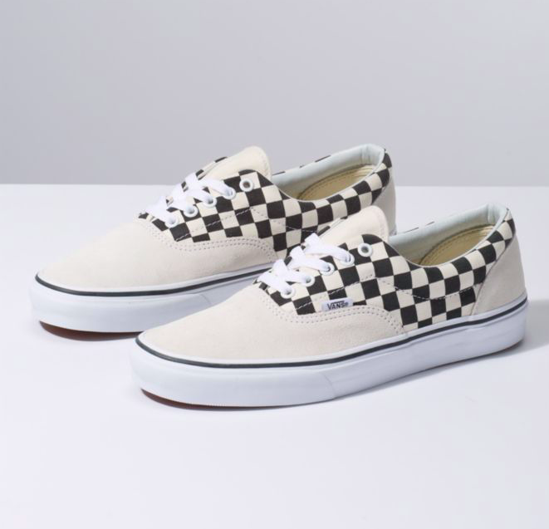

vans PRIMARY CHECK ERA

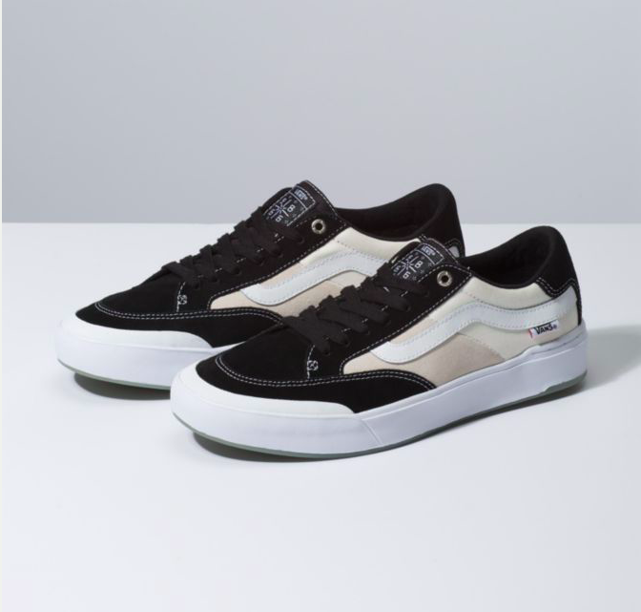

vans BERLE PRO

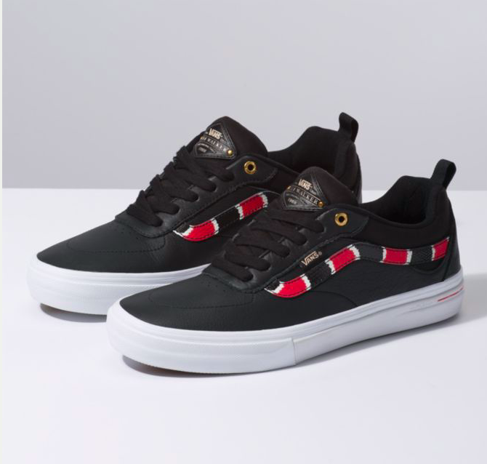

vans CORAL SNAKE KYLE WALKER PRO

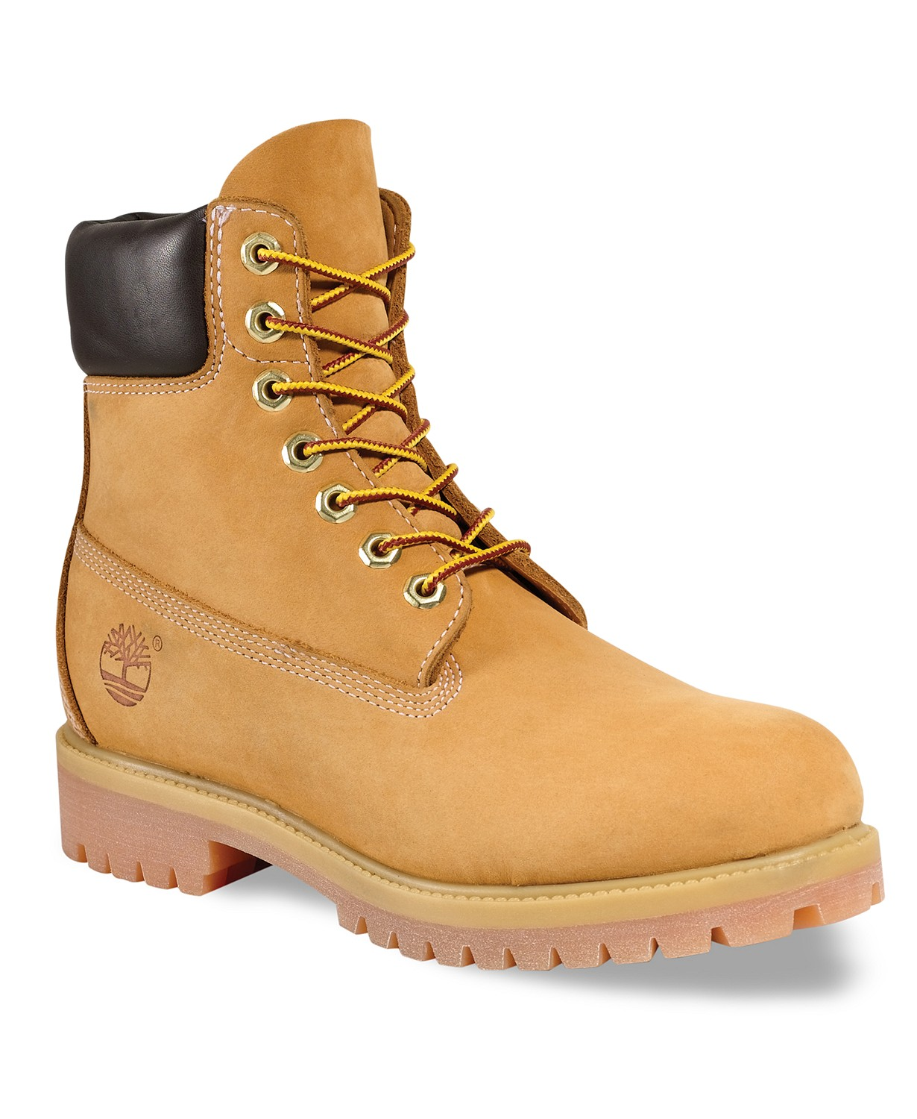

#### [Timberland](https://www.macys.com/shop/featured/timberland) Men's 6" Premium Waterproof Boots

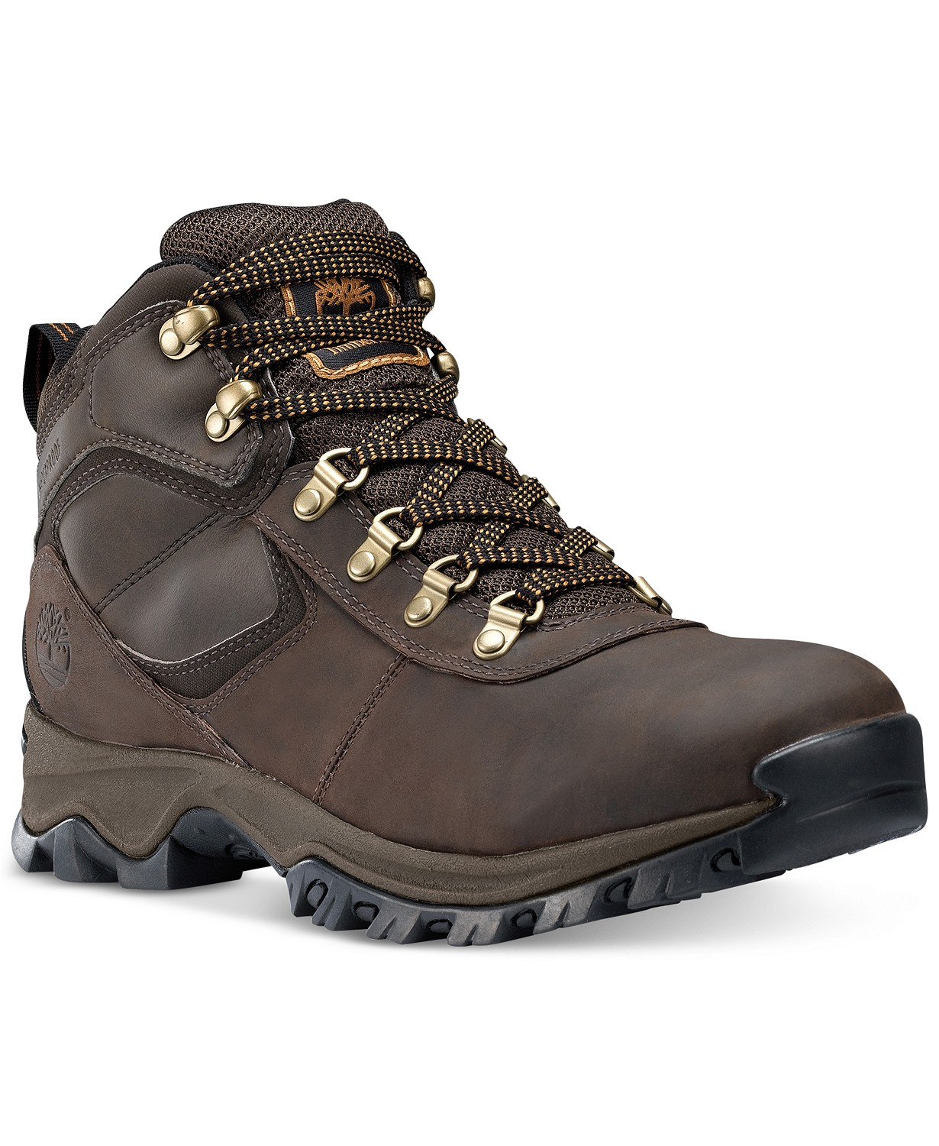

#### [Timberland](https://www.macys.com/shop/featured/timberland) Men's Mt. Maddsen Waterproof Hiking Boots

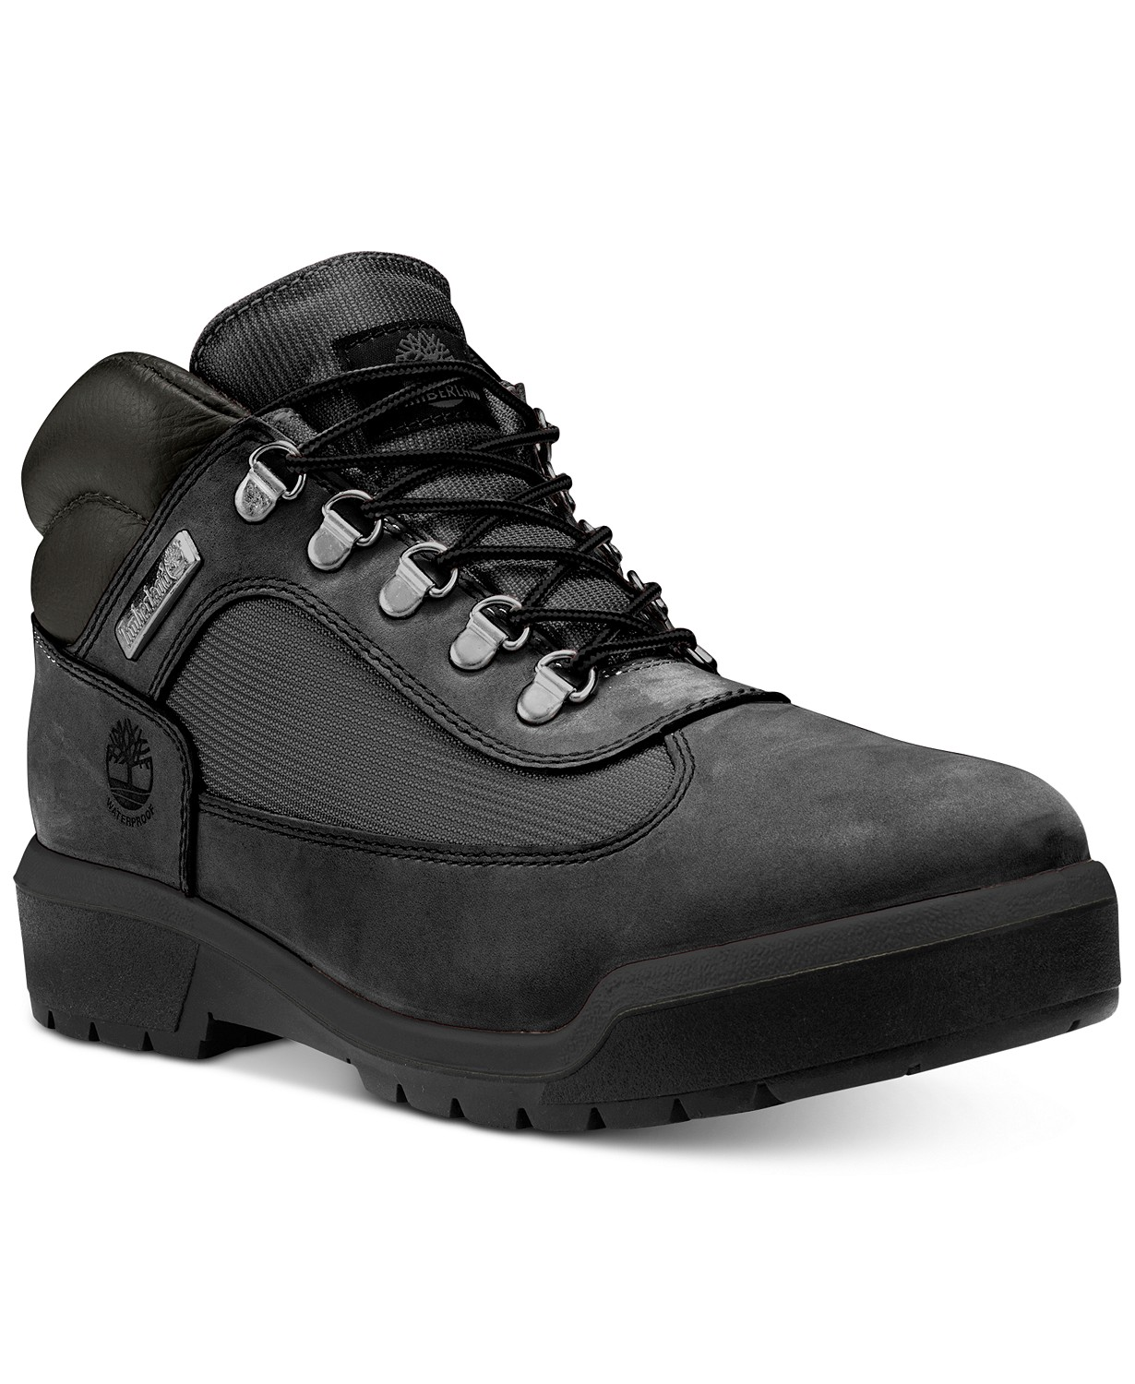

#### [Timberland](https://www.macys.com/shop/featured/timberland) Men's Waterproof Field Boots

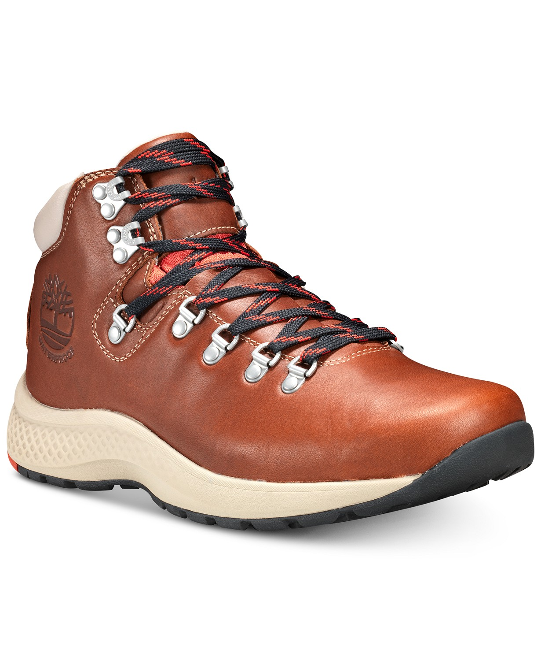

#### [Timberland](https://www.macys.com/shop/featured/timberland) Men's FlyRoam Trail Hiker

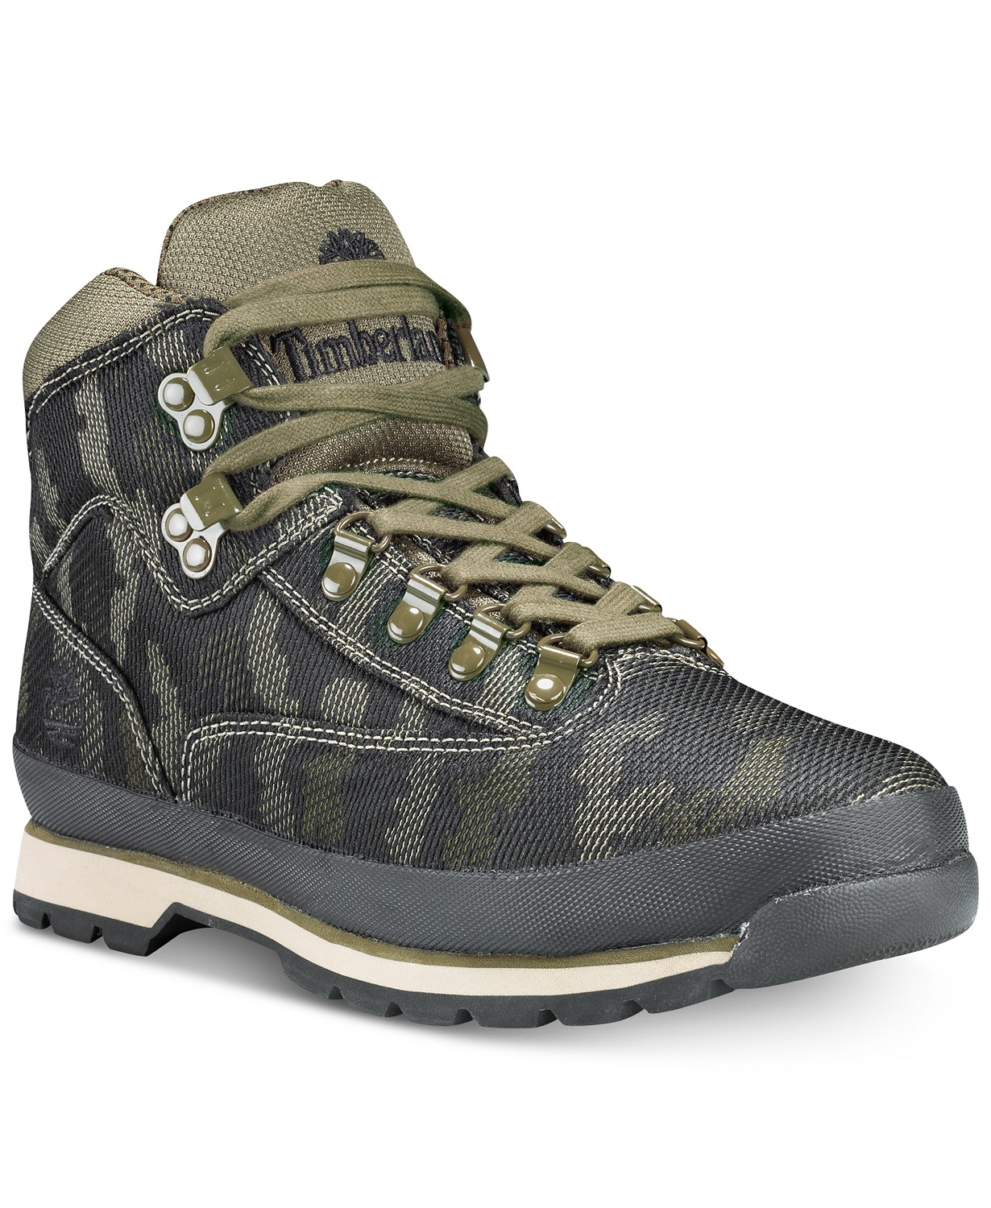

#### [Timberland](https://www.macys.com/shop/featured/timberland) Men's Euro Hiker Jacquard Boots